Department of Computer Science

Faculty Member: <> Date: <>
Semester: <>

Computer Vision
Lab 8: Introduction to Deep Learning with TensorFlow – Implementing a Simple CNN on MNIST

Introduction
In this laboratory exercise, you will get started with deep learning using TensorFlow, one of the most popular frameworks for building and training neural networks. You will begin by exploring TensorFlow’s official beginner guide, understanding how a simple neural network (Multi-Layer Perceptron) is built and trained. Then, you will extend that example by implementing a Convolutional Neural Network (CNN) to solve the same MNIST handwritten digit classification problem. The goal of this lab is to help you understand how deep learning models are structured, how they learn from data, and why CNNs are more effective for image-based tasks than traditional fully connected networks.

Objectives
- Get familiar with TensorFlow and Keras environments.
- Learn how to set up a virtual environment and install TensorFlow.
- Understand the basic components of a deep learning model: layers, activation functions, optimizer, and loss.
- Implement and train a simple CNN to classify handwritten digits from the MNIST dataset.
- Compare CNNs with simple dense (MLP) architectures and discuss why CNNs are preferred for visual data.
Lab Tasks – Implementing Popular CNN Architectures in TensorFlow
In this task, you will implement five well-known convolutional neural network (CNN) architectures in TensorFlow/Keras to deepen your understanding of modern deep learning models. Each model will first be created manually by concatenating appropriate layers, and then implemented again using TensorFlow’s built-in pretrained versions. You will refer to the provided architecture diagrams for layer details and configurations.

Task 1.1, implement AlexNet using TensorFlow’s Keras API by defining each layer manually in a Sequential or Functional model. Use the provided image of the AlexNet architecture as a reference for the correct number of filters, kernel sizes, and fully connected layers. Build and train the model on your custom image classification dataset.

In Task 1.2, implement VGG-16 by stacking convolutional, pooling, and dense layers exactly as shown in the VGG-16 architecture diagram. Train the custom-built model on your dataset, then load the pretrained VGG16 model from tensorflow.keras.applications, fine-tune its final layers, and compare both models in terms of accuracy, loss, and training time.

In Task 1.3, create VGG-19 in the same way, referring to the provided diagram for layer counts and structure. Train your custom VGG-19 model on the dataset and then use TensorFlow’s pretrained VGG19 model for comparison. Discuss the performance difference caused by the deeper architecture.

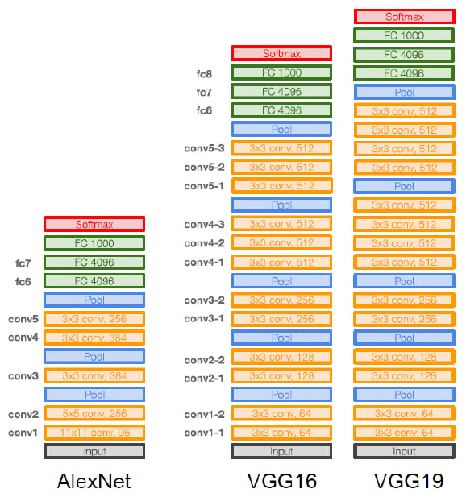

In Task 1.4, implement GoogLeNet (Inception v1) by defining the Inception modules as shown in the reference image. Construct the network by concatenating convolutional paths with different filter sizes within each module, and train it using the same dataset. Compare its feature extraction performance with the previous VGG models.

In Task 1.5, implement ResNet using TensorFlow by building residual blocks that include skip (shortcut) connections between layers, following the structure shown in the provided diagram. Train your custom ResNet model and then use the pretrained ResNet50 model from tensorflow.keras.applications for evaluation. Analyze how the use of residual connections helps overcome the vanishing gradient problem and improves performance for deeper networks.
